(AI Jobs) Power BI Data Model Documentation
1. Project Overview
This document describes the full ETL process, data transformations, and DAX measures used in the Power BI model. The model is built using multiple dimension tables and one fact table to support analytical reporting related to jobs, AI impact, economy, skills, and workforce trends.

2. Data Sources
All data is imported from CSV files:
The model consists of the following tables:
Dimension Tables
- Dim_Economy_Context
- Dim_Experience
- Dim_Industry
- Dim_Job_Role
- Dim_Productivity
- Dim_Salary_Analytics
- Dim_Location
- Dim_Skillset (2 models: Index + Unpivoted Skills)
- Dim_Work_Mode
- Dim_Demographics
- Dim_Date
- Dim_Company
- Dim_AI_Investment
- Dim_AI_Impact
Fact Table
- Fact_Job_Snapshot

3. Power Query Transformations (Advanced Editor Summary)
Common Steps Applied Across Tables
- Promote Headers
- Change Data Types
- Remove Unnecessary Columns
- Replace Values
- Remove Duplicates
- Add Index (Location)
- Split Columns (Job Title, Skill Status)
- Unpivot Columns (Skills)
Special Treatments
Dim_Job_Role
- Split JobTitle into numeric and text part
- Replace "Nurse" with "Machine Learning Engineer"
- Remove Description and Job Family
Dim_Location
- Recreated LocationKey using index column
Dim_Skillset
Two models created:
- Skill Index Table (distinct Skill_Gap_Index)
- Unpivoted Skill Table with Skill_Status
Dim_Company
- Removed "Inc." from company names
- Duplicated CompanySize column

4. Data Cleaning Rules
- Remove irrelevant columns
- Replace Null values where needed
- Remove duplicates based on business logic
- Standardize text (trim, rename, replace)

5. DAX Measures
KPIs
Total Job Count = SUM(_Fact_Job_Snapshot[JobCount])
Total Emerging Jobs =
CALCULATE([Total Job Count], Dim_Job_Role[Job_Status] = "Emerging")
Total Declining Jobs =
CALCULATE([Total Job Count], Dim_Job_Role[Job_Status] = "Declining")
Emerging-to-Declining Job Ratio =
DIVIDE([Total Emerging Jobs],[Total Declining Jobs])

Averages
Avg AI Adoption Rate =
DIVIDE(
SUMX('_Fact_Job_Snapshot', '_Fact_Job_Snapshot'[JobCount] * RELATED('Dim_Industry'[AI_Adoption_Rate_Pct])),
[Total Job Count])
Avg AI Investment Level USD = AVERAGE(Dim_AI_Investment[AI_Investment_Level_USD])
Avg AI ROI Rate = DIVIDE(AVERAGE(Dim_AI_Investment[AI_Return_on_Investment_ROI_Score]),3)
Avg Automation Risk = AVERAGE(Dim_AI_Impact[Automation_Risk_Percentage])
Avg Productivity Gain = AVERAGE(Dim_Productivity[AI_Productivity_Gain_Pct])
Avg Quality Improvement = AVERAGE(Dim_AI_Impact[Quality_Improvement_Pct])
Avg Time Saved Per Week = AVERAGE(Dim_Productivity[Time_Saved_per_Week_Hours])
Avg Inflation Rate = AVERAGE(Dim_Economy_Context[Inflation_Rate_Pct])
Avg GPA Growth Rate = AVERAGE(Dim_Economy_Context[GDP_Growth_Rate_Pct])
Avg Turnover Rate = AVERAGE(Dim_Economy_Context[Turnover_Rate_Avg_Pct])
Avg Skill Gap Index = AVERAGE(Dim_Skillset[Skill_Gap_Index])

6. Data modeling

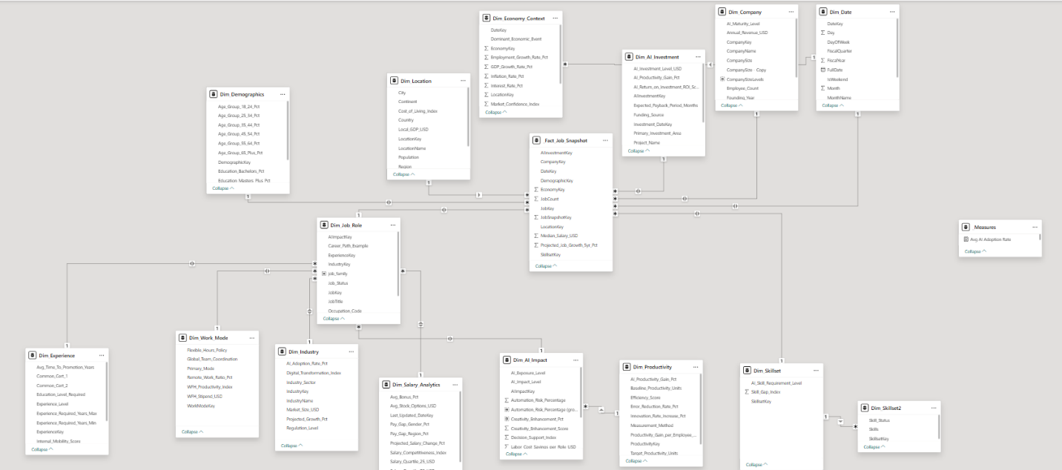

The image provided confirms the Star Schema with Snowflaking design for your Job Analytics data model, which aligns with the relationships previously identified.
Data Model Structure: Star Schema with Snowflaking
The core of the model is the central Fact Table, Fact_Job_Snapshot, which records job-related metrics. It is surrounded by primary Dimension Tables that provide context.
1. Central Fact Table
- Fact_Job_Snapshot: This is the primary table containing quantifiable metrics for jobs, such as Median_Salary_USD, Projected_Job_Growth_5yr_Pct, and JobCount. It is linked to the primary dimensions through foreign keys.
2. Primary Dimensions (Directly connected to Fact)
These tables provide the main slicing and filtering capabilities for the Fact_Job_Snapshot:
- Dim_AI_Investment: Context on AI funding.
- Dim_Company: Company-specific details.
- Dim_Date: Time intelligence for reporting.
- Dim_Demographics: Demographic breakdown of the workforce.
- Dim_Job_Role: Core job title and classification details (acts as a mini-fact/hub).
- Dim_Location: Geographical information.
- Dim_Skillset: Primary skillset context.
- Dim_Economy_Context: Economic indicators (Inflation, GDP, etc.) (Note: This links to Dim_Date, but is often treated as a fact-like dimension).
3. Snowflaked Dimensions (Connected via another Dimension)
These tables are linked to Fact_Job_Snapshot indirectly through a primary dimension, specifically Dim_Job_Role and Dim_AI_Impact. This normalization reduces redundancy but adds complexity (Snowflaking):
Secondary Dimension | Connected Via | Purpose
Dim_Experience | Dim_Job_Role | Experience requirements and time-to-promotion.
Dim_Work_Mode | Dim_Job_Role | Remote work ratio, primary work mode, and policy details.
Dim_Industry | Dim_Job_Role | Industry sector, growth, and AI adoption rates.
Dim_Salary_Analytics | Dim_Job_Role | Detailed salary quartile, bonus, and pay gap information.
Dim_AI_Impact | Dim_Job_Role | Automation risk, task elimination, and productivity gains due to AI.
Dim_Productivity | Dim_AI_Impact | Baseline productivity units and error reduction rates.
4. Supporting Tables
- Dim_Skillset2: This table, linked to Dim_Skillset, likely contains the unpivoted skills data (as seen in the Power Query steps) used for detailed skill analysis, separated from the main skillset index table to maintain a clean structure.
- Measures: This is a common practice to group and organize all DAX measures (like Avg AI Adoption Rate) into a single dummy table for better dashboard organization.
Implications of this Modeling
- Flexibility in Analysis: You can analyze job metrics (JobCount) by any primary dimension (e.g., location, date, company) or by the snowflaked dimensions (e.g., filter jobs by Primary_Mode from Dim_Work_Mode).
- Performance: The Star Schema provides fast query performance for core metrics, while the Snowflaking on attributes like Experience and Industry ensures efficient data storage and reduced redundancy.
- DAX Calculations: Measures like Avg AI Adoption Rate rely on this structure. The DAX engine traverses the relationships from the Fact_Job_Snapshot through Dim_Job_Role to Dim_Industry to correctly calculate the weighted average of AI Adoption Rate per job.

7. Visuals

